**HOW TO PUBLISH SPLAT WITH IIS USING VISUAL STUDIO**

***The source code for SPLAT can be found in the following Github:***

<https://github.com/ducanhvn99/SPLAT.git>

***Make sure to Build the project with no errors (warnings are acceptable) before publishing.***

The SPLAT version that uses .Net 7 uses yarn to complete the installation of dependencies, so it is recommended to use yarn for future updates.

How to replace the npm command with yarn and equivalent npm command in yarn: <https://classic.yarnpkg.com/lang/en/docs/migrating-from-npm/>

***Configure the Publish setting.***

The Publish page should have the setting like this: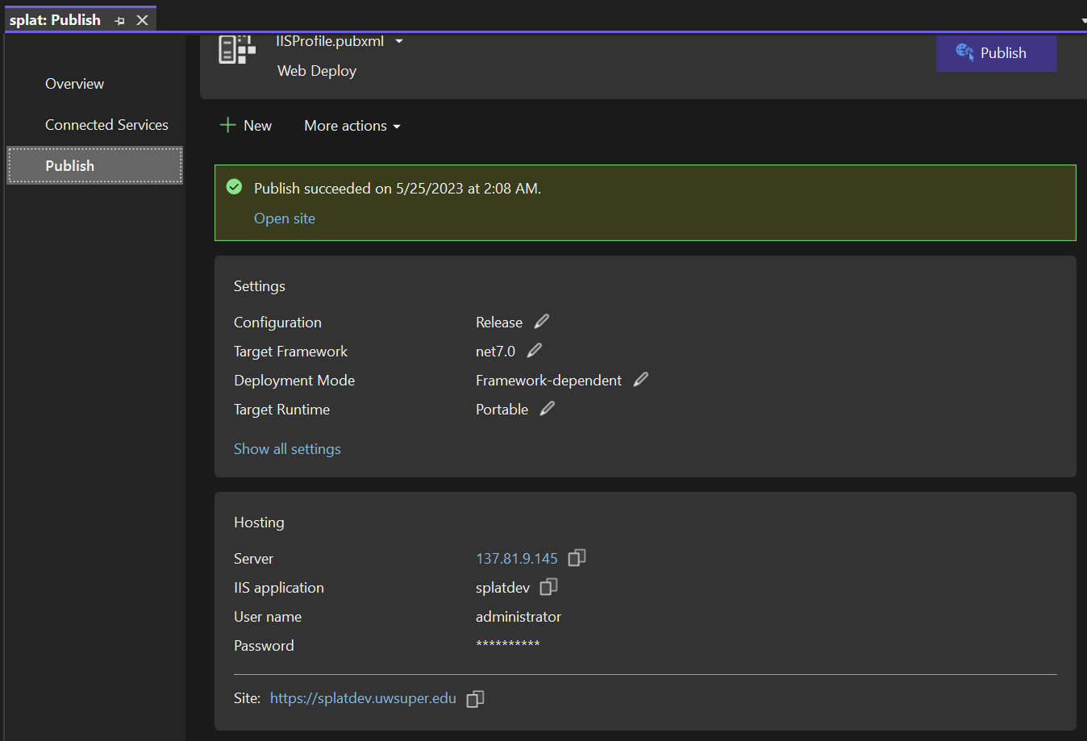

Note: the account that use to publish the website is MCS/administrator. The username and password can be acquired through Password Manager Pro (PMP).

For access to PMP, contact System Admin from Technology Services.

Attached is the publish profile that was used to publish the staging environment.



***Remote to SUP server and complete the setup there.***

Contact System Admin from Technology Services for an account to remote to the server.

***Open Internet Information Service Manager (IIS) on the SUP server.***

***Create a new application pool in IIS for the new website to use:***

How to create a new application pool: <https://prod.docs.oit.proofpoint.com/installation_guide/creating_a_new_application_pool_in_iis_8.x.htm>

***Go to Binding and configure the setting in there (you can copy the setting for existing SPLAT website).***

How to add binding information to a site: <https://learn.microsoft.com/en-us/iis/configuration/system.applicationhost/sites/site/bindings/binding>

***Choose the working SSL (Secure Sockets Layer) certificate for the website***

If there are no working SSL certificates or the SSL certificate has expired, contact System Admin from Technology Services.

***Try to open the website to see if the publication is working (you may need to clear the web browser cache for the change to apply).***

If the new publication is not working, try replacing the Client App folder and/or the appsetting.json file with the working version of the existing SPLAT website